Test Case: tc002_SPX_Dev5_Crear_Requisicion_Spot_Con_FAD_Tipo_Cobro_CC
Step 1 - Enter username and password and click to button Enter : Credentials Entered
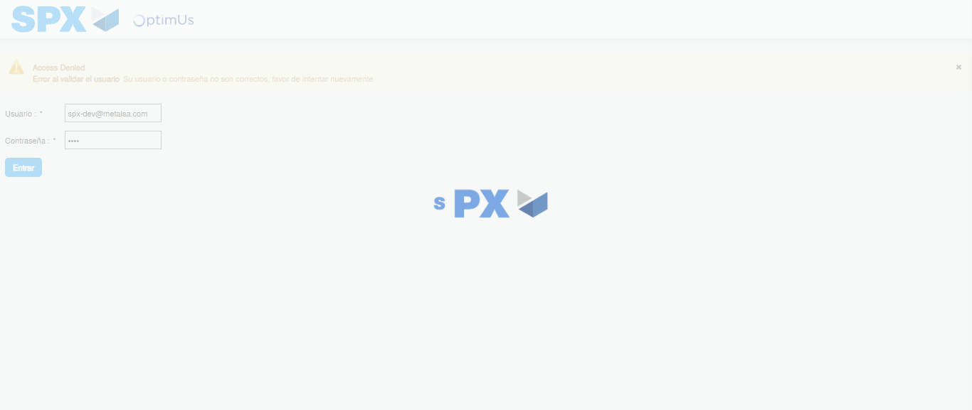Image file-name: QC_Testing-tc002_SPX_Dev5_Crear_Requisicion_Spot_Con_FAD_Tipo_Cobro_CC-1785343711219

Step 2 - Select to UEN and Access to Spot Buy Requisitions : UEN Correctly selected and Correct access
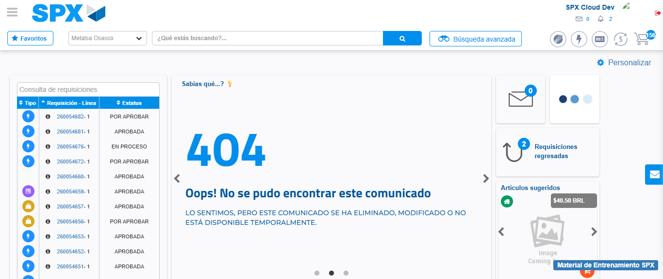Image file-name: QC_Testing-tc002_SPX_Dev5_Crear_Requisicion_Spot_Con_FAD_Tipo_Cobro_CC-1785343741380

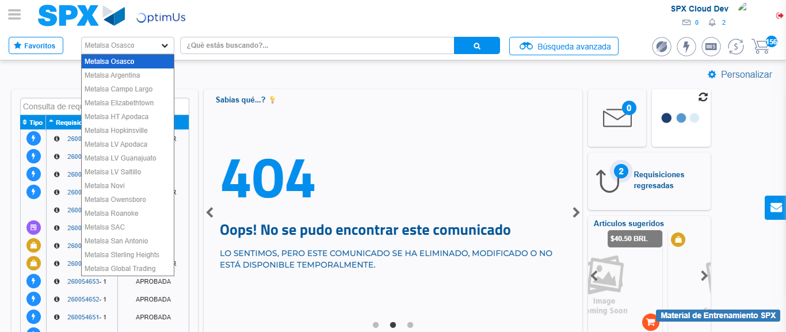Image file-name: QC_Testing-tc002_SPX_Dev5_Crear_Requisicion_Spot_Con_FAD_Tipo_Cobro_CC-1785343743930

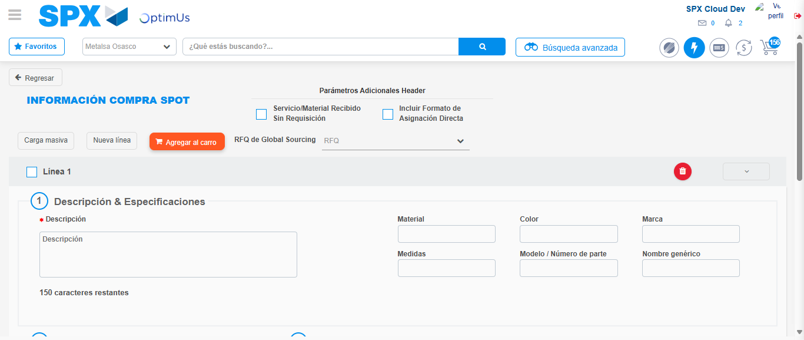Image file-name: QC_Testing-tc002_SPX_Dev5_Crear_Requisicion_Spot_Con_FAD_Tipo_Cobro_CC-1785343763900

Step 3 - Add FAD to Requisition: FAD Successfully Added
Image file-name: QC_Testing-tc002_SPX_Dev5_Crear_Requisicion_Spot_Con_FAD_Tipo_Cobro_CC-1785343764144

Image file-name: QC_Testing-tc002_SPX_Dev5_Crear_Requisicion_Spot_Con_FAD_Tipo_Cobro_CC-1785343764349

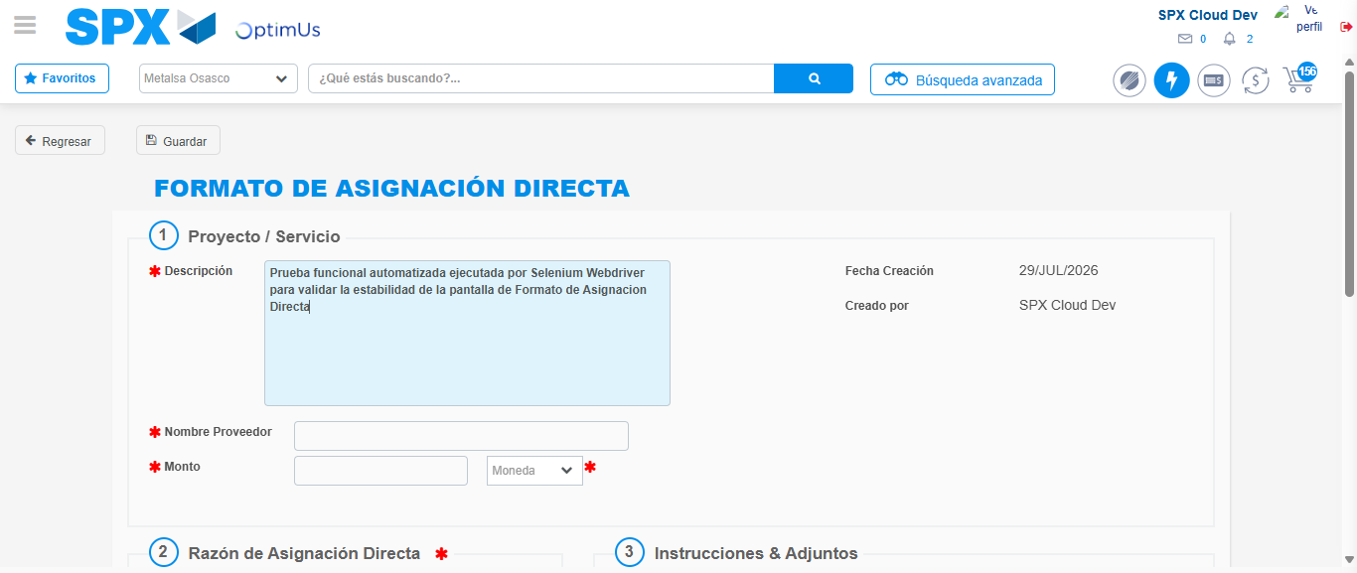Image file-name: QC_Testing-tc002_SPX_Dev5_Crear_Requisicion_Spot_Con_FAD_Tipo_Cobro_CC-1785343767040

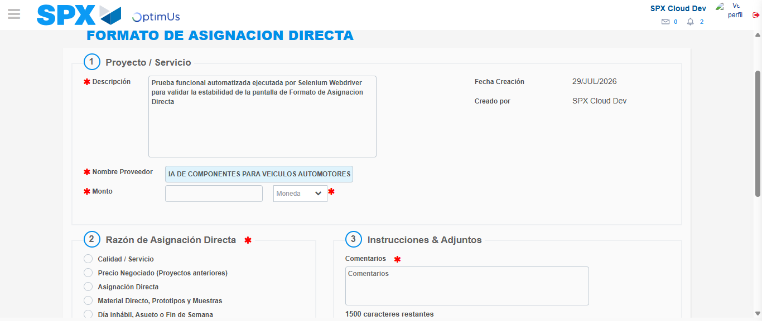Image file-name: QC_Testing-tc002_SPX_Dev5_Crear_Requisicion_Spot_Con_FAD_Tipo_Cobro_CC-1785343776174

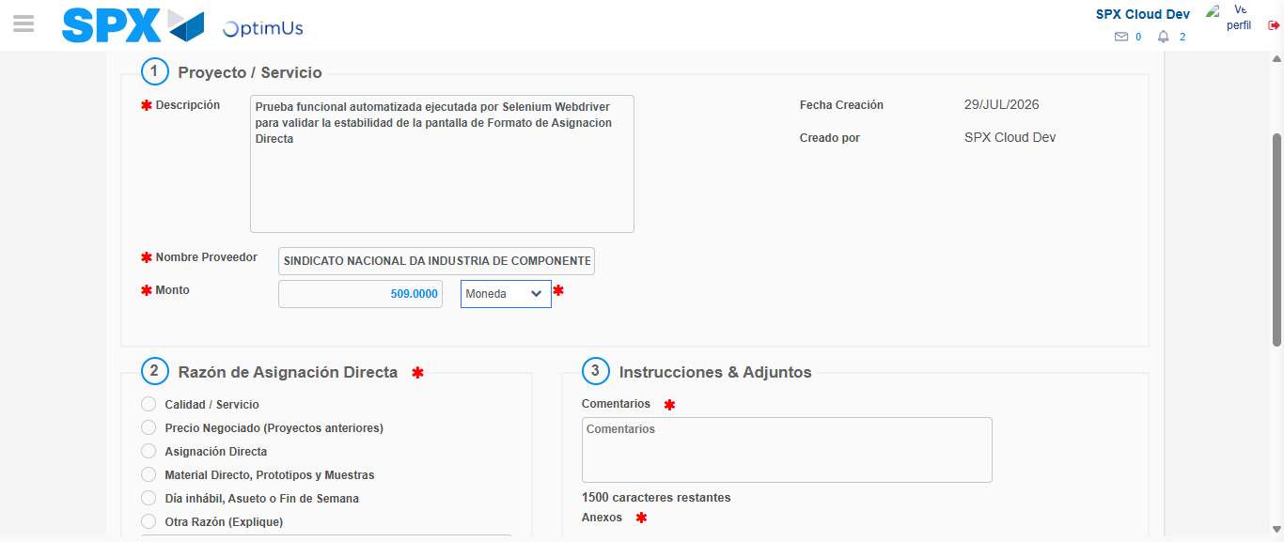Image file-name: QC_Testing-tc002_SPX_Dev5_Crear_Requisicion_Spot_Con_FAD_Tipo_Cobro_CC-1785343776557

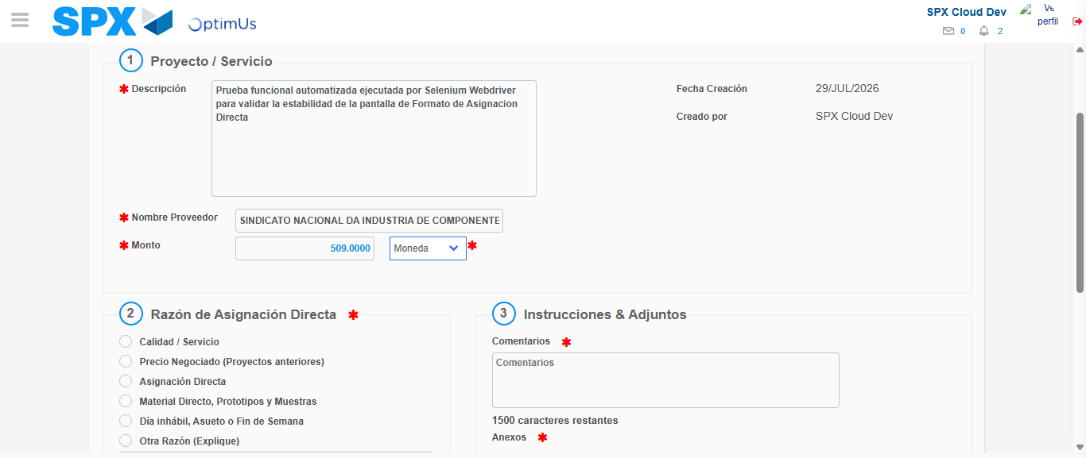Image file-name: QC_Testing-tc002_SPX_Dev5_Crear_Requisicion_Spot_Con_FAD_Tipo_Cobro_CC-1785343776761

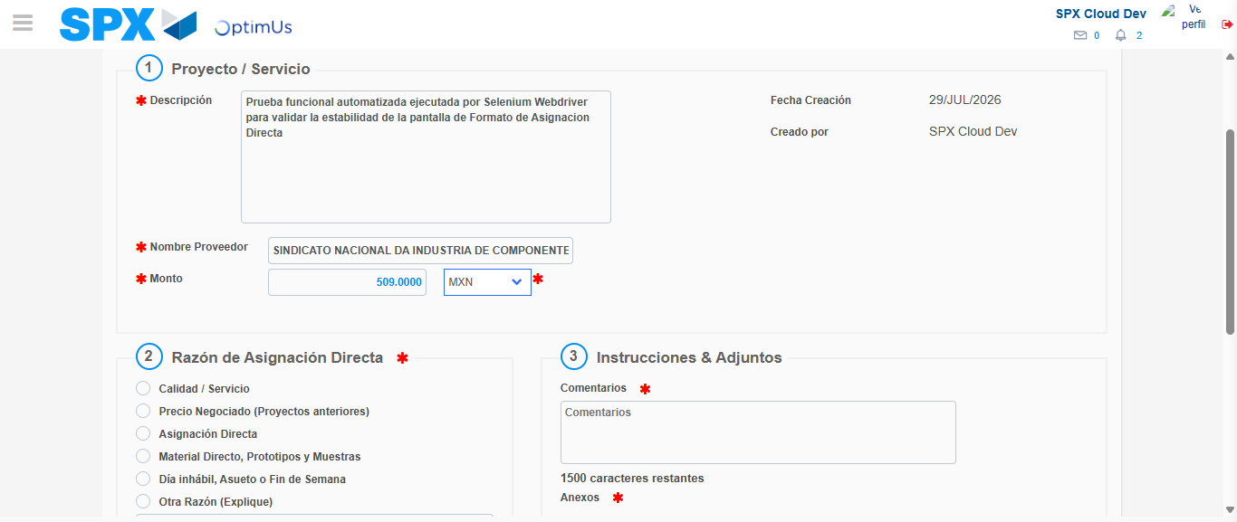Image file-name: QC_Testing-tc002_SPX_Dev5_Crear_Requisicion_Spot_Con_FAD_Tipo_Cobro_CC-1785343777072

Image file-name: QC_Testing-tc002_SPX_Dev5_Crear_Requisicion_Spot_Con_FAD_Tipo_Cobro_CC-1785343777237

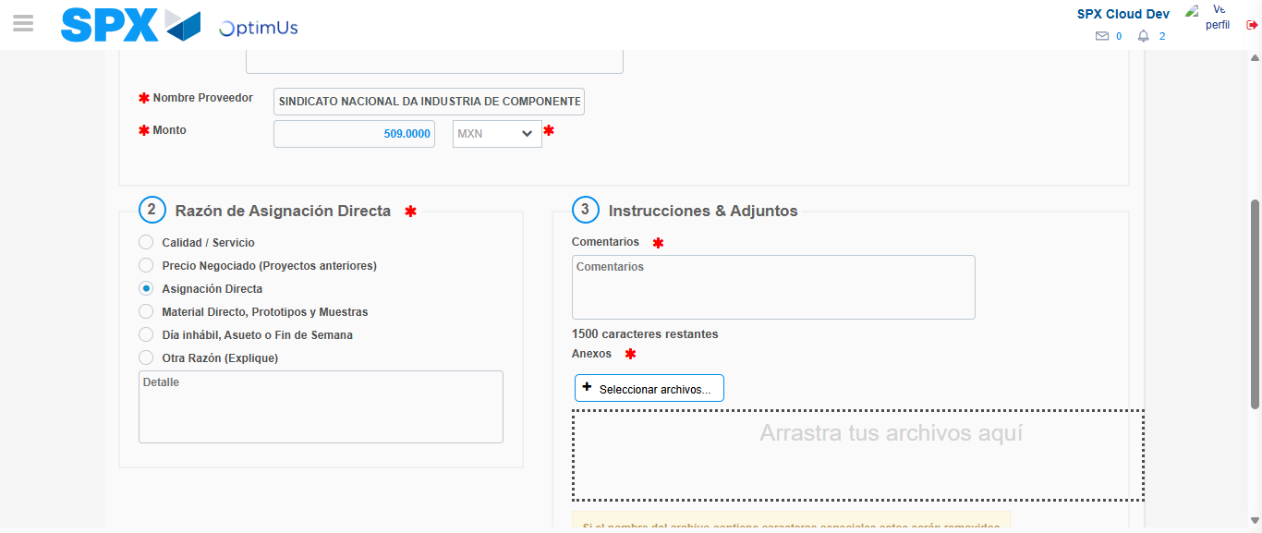Image file-name: QC_Testing-tc002_SPX_Dev5_Crear_Requisicion_Spot_Con_FAD_Tipo_Cobro_CC-1785343778023

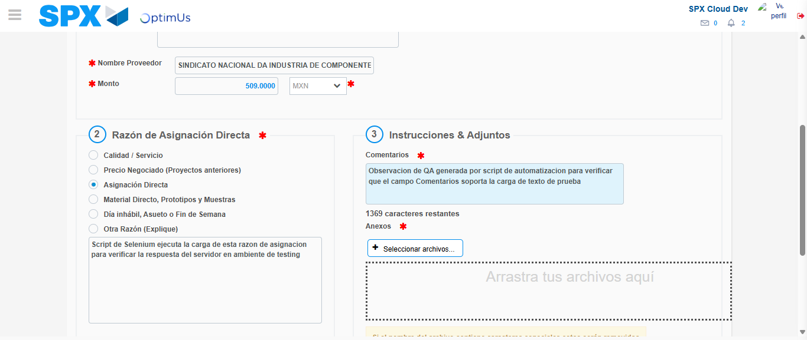Image file-name: QC_Testing-tc002_SPX_Dev5_Crear_Requisicion_Spot_Con_FAD_Tipo_Cobro_CC-1785343789059

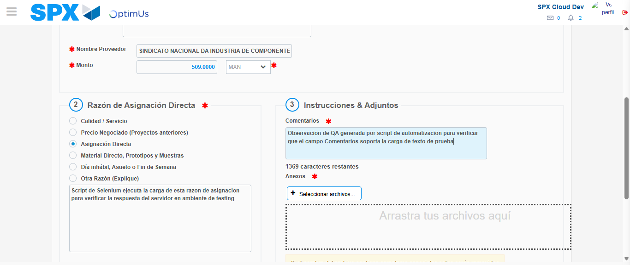Image file-name: QC_Testing-tc002_SPX_Dev5_Crear_Requisicion_Spot_Con_FAD_Tipo_Cobro_CC-1785343789636

Step 4 - Data Capture Spot Buy Requisition: Data captured correctly
Image file-name: QC_Testing-tc002_SPX_Dev5_Crear_Requisicion_Spot_Con_FAD_Tipo_Cobro_CC-1785343764144

Image file-name: QC_Testing-tc002_SPX_Dev5_Crear_Requisicion_Spot_Con_FAD_Tipo_Cobro_CC-1785343764349

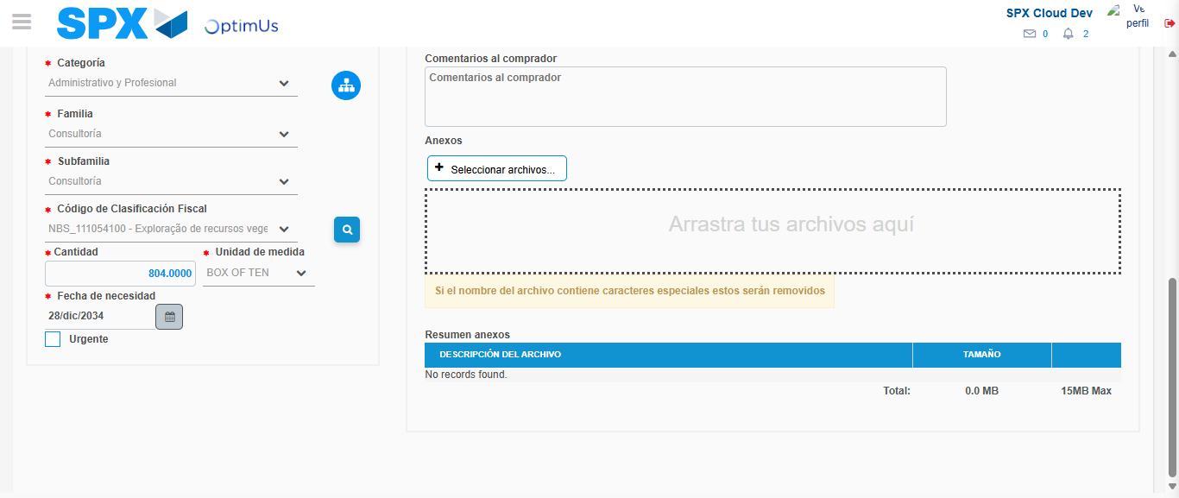Image file-name: QC_Testing-tc002_SPX_Dev5_Crear_Requisicion_Spot_Con_FAD_Tipo_Cobro_CC-1785343803245

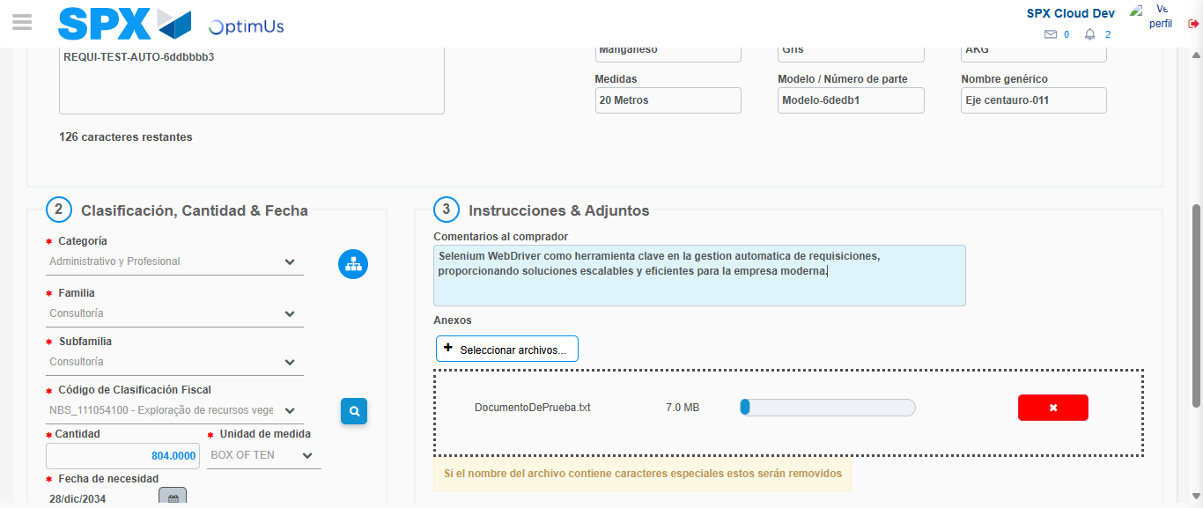Image file-name: QC_Testing-tc002_SPX_Dev5_Crear_Requisicion_Spot_Con_FAD_Tipo_Cobro_CC-1785343803973

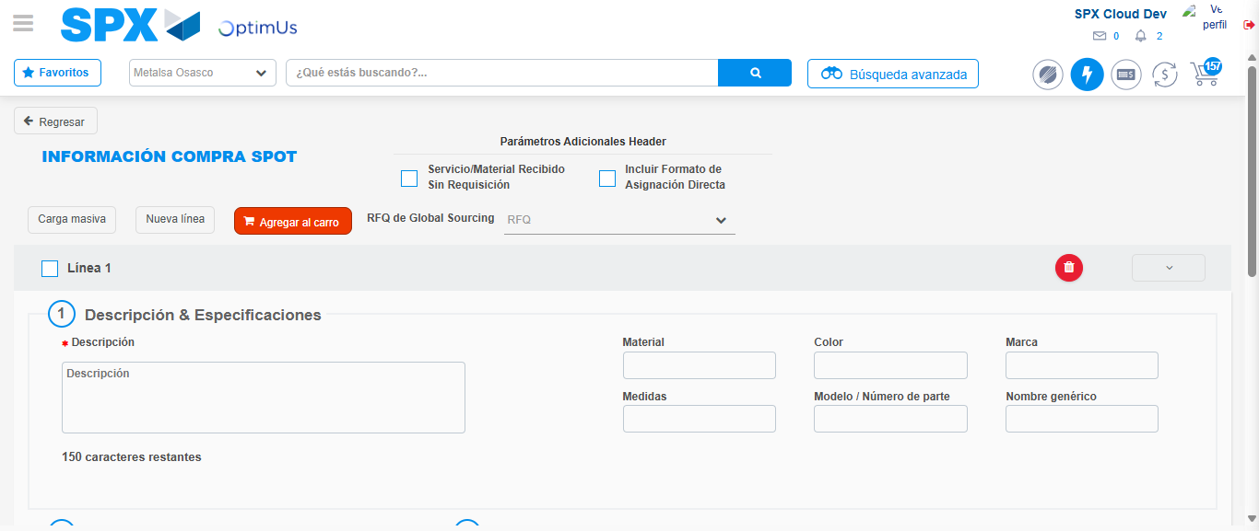Image file-name: QC_Testing-tc002_SPX_Dev5_Crear_Requisicion_Spot_Con_FAD_Tipo_Cobro_CC-1785343812909

Step 8 - Return to Main Page SPX : Return to Main Page SPX
Image file-name: QC_Testing-tc002_SPX_Dev5_Crear_Requisicion_Spot_Con_FAD_Tipo_Cobro_CC-1785343741380

Image file-name: QC_Testing-tc002_SPX_Dev5_Crear_Requisicion_Spot_Con_FAD_Tipo_Cobro_CC-1785343743930

Image file-name: QC_Testing-tc002_SPX_Dev5_Crear_Requisicion_Spot_Con_FAD_Tipo_Cobro_CC-1785343763900

Image file-name: QC_Testing-tc002_SPX_Dev5_Crear_Requisicion_Spot_Con_FAD_Tipo_Cobro_CC-1785343815154

Image file-name: QC_Testing-tc002_SPX_Dev5_Crear_Requisicion_Spot_Con_FAD_Tipo_Cobro_CC-1785343815319

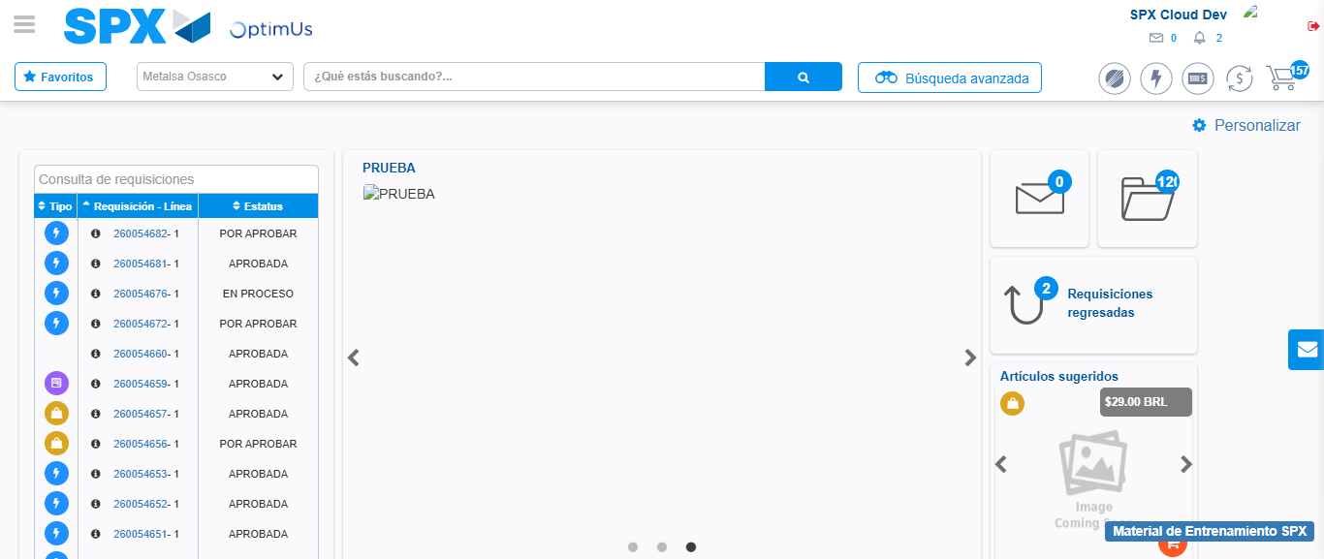Image file-name: QC_Testing-tc002_SPX_Dev5_Crear_Requisicion_Spot_Con_FAD_Tipo_Cobro_CC-1785343836414

Step 9 - Log Out : Log Out SPX
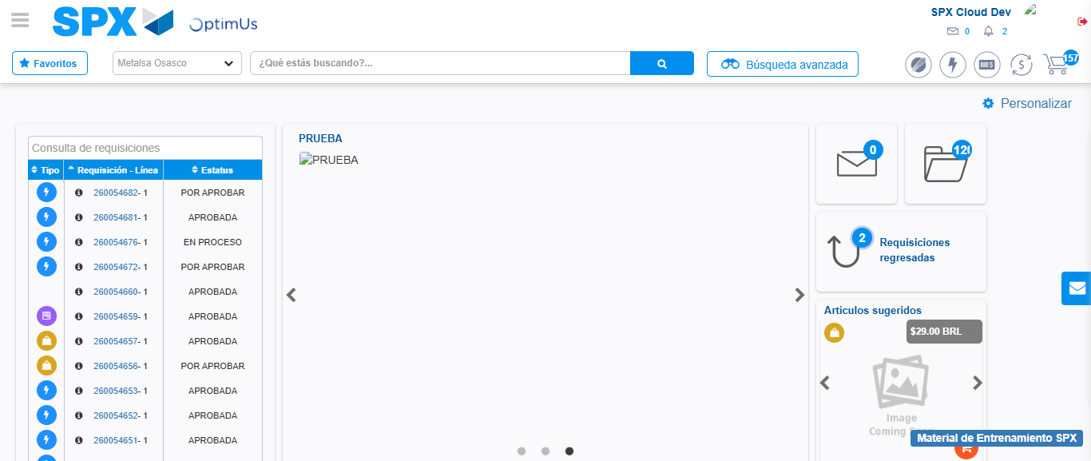Image file-name: QC_Testing-tc002_SPX_Dev5_Crear_Requisicion_Spot_Con_FAD_Tipo_Cobro_CC-1785343836685

